E-COMMERCE ORDER MANAGEMENT DATABASE SYSTEM
4. ORDERS & ORDER_DETAILS TABLE DESIGN
This document describes the design of the Orders and Order_Details tables for the E-Commerce Order Management Database System. It defines the fields, data types, constraints, relationships and purpose of each attribute.

1. Orders Table
The Orders table stores and maintains customer order information. Each order is linked to the customer who placed it. Suitable data types and constraints help ensure that the stored order information is valid and consistent.
S.No | Field Name | Data Type | Constraint | Description
1 | Order_ID | INT | PRIMARY KEY | Uniquely identifies each order.
2 | Customer_ID | INT | FOREIGN KEY, NOT NULL | Connects the order with its customer.
3 | Order_Date | DATE | NOT NULL | Stores the date on which the order was placed.
4 | Total_Amount | DECIMAL(10,2) | NOT NULL, CHECK | Stores the total amount of the order; must not be negative.
5 | Order_Status | VARCHAR(20) | NOT NULL, CHECK | Stores the current order status.

2. Order_Details Table
The Order_Details table stores the individual product items associated with each order. An order may contain multiple products, and each row records the product, quantity and price for one order item.
S.No | Field Name | Data Type | Constraint | Description
1 | Order_Detail_ID | INT | PRIMARY KEY, AUTO_INCREMENT | Uniquely identifies each order-detail record.
2 | Order_ID | INT | FOREIGN KEY, NOT NULL | Connects the detail record with its corresponding order.
3 | Product_ID | INT | FOREIGN KEY, NOT NULL | Connects the order detail with its product.
4 | Quantity | INT | NOT NULL, CHECK | Stores the quantity ordered; must be greater than zero.
5 | Price | DECIMAL(10,2) | NOT NULL, CHECK | Stores the product price for this order item; must not be negative.

3. Attribute Description
· Order_ID: A unique identifier assigned to each customer order.
· Customer_ID: Identifies the customer who placed the order.
· Order_Date: Stores the date when the order was placed.
· Total_Amount: Stores the total monetary amount of the order.
· Order_Status: Stores the order status. The permitted values are Pending, Shipped, Delivered and Cancelled.
· Order_Detail_ID: A unique identifier for each individual order-detail record. It is generated automatically.
· Product_ID: Identifies the product included in the order detail.
· Quantity: Stores the number of units of the product ordered.
· Price: Stores the price of one unit of the product at the time of the order.

4. Constraints
· PRIMARY KEY: Uniquely identifies every record in the Orders and Order_Details tables.
· AUTO_INCREMENT: Automatically generates a new Order_Detail_ID for each inserted order-detail record.
· NOT NULL: Ensures that required fields contain a value.
· FOREIGN KEY: Establishes relationships between Customer, Orders and Product tables.
· CHECK: Ensures Total_Amount and Price are not negative, and Quantity is greater than zero.
· CHECK on Order_Status: Restricts Order_Status to Pending, Shipped, Delivered or Cancelled.
· ON UPDATE CASCADE: Propagates an updated referenced key value to matching foreign-key values, where this action is defined.
· ON DELETE CASCADE: Deletes related Order_Details records automatically when their parent order is deleted.
· ON DELETE RESTRICT: Prevents deletion of a referenced customer or product while dependent records exist.

5. Table Relationships
The tables are connected using the following foreign-key relationships:
· Customer.Customer_ID → Orders.Customer_ID (one customer can place many orders).
· Orders.Order_ID → Order_Details.Order_ID (one order can contain many order-detail records).
· Product.Product_ID → Order_Details.Product_ID (one product can appear in many order-detail records).

6. Screenshots
Insert screenshots captured from your own MySQL Workbench execution in the spaces below. The placeholders are provided for report formatting; they are not actual execution screenshots.
Figure 1: Orders Table Creation
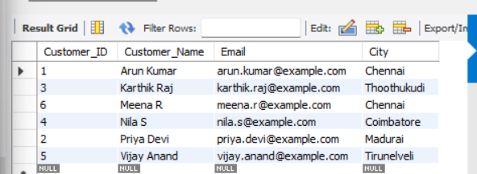

Figure 2: Table Creation Verification
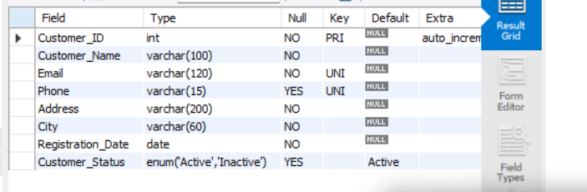

7. Conclusion
The Orders and Order_Details tables provide the required structure for storing customer order information and managing the products associated with each order in the E-Commerce Order Management Database System. The defined attributes, data types, relationships and constraints help maintain accurate, organized and consistent order data.

